Examination: VIII Sem. B.Tech (Mining Engineering) Session: 2021-22
Semester: Monsoon Semester Max. Marks: 100
Subject: Mine Systems Engineering Time: 3 Hrs.
Section 1 (Attempt any 2 Questions OUT OF 3) Total Marks 40
Q1. This is a Project Network with Probabilistic Time Estimates (PERT). Assume a Beta distribution for this network. The numbers given in the activity are in the same order. (10 Marks)
a = optimistic estimate
m = most likely time estimate
b = pessimistic time estimate
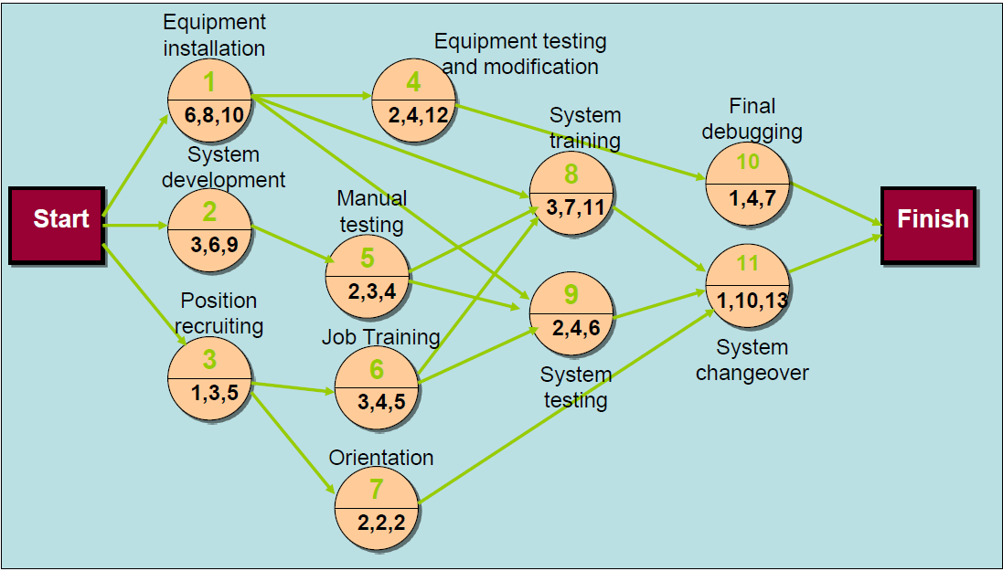
Calculate the following based on the graph above:
- What is the Mean (expected time) and Variance of each activity from 1 to 11
- What is the Activity (from 1 to 11) Early, Late Times, and Slack
- Total Project Variance
- Determine probability that project is completed within 30 weeks ( Z score of 1.91 corresponds to a probability of 0.9719)

Q2. A mining project has activities with the following normal and crash times and cost. Determine a crashing scheme for the above project so that the total project time is reduced by 3 weeks. (10 Marks)
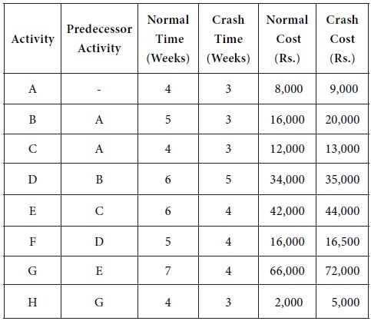

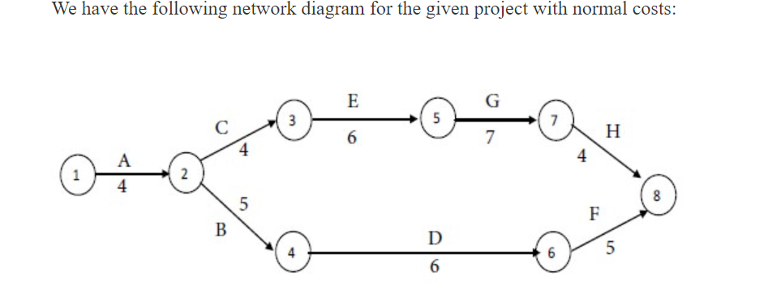

Q3. Suppose a mining company manufactures two products, A and B, using three inputs, labor, material R, and materials S. To make one unit of product A requires 6 pounds of R, 7.5 pounds of S, and 9 person-hours of labor; to make one unit of product B requires 12 pounds of R, 4.5 pounds of S, and 6 person-hours of labor. The demands for the products are such that the company can sell as much of each product as it can produce and earn a profit of $3 per unit of A and $4 per unit of B. However, only 900 pounds of R, 675 pounds of S, and 1200 person-hours of labor are available to the company each day. (10 Marks)
a. Formulate the company’s problem as a linear program to maximize profit.
b. Graph the feasible region for this problem.
c. Solve the problem graphically by finding the best extreme point.

Q4. Each year, the Smalltown Mining company sells 10,000 tons of coal to a power plant. The mining company orders batteries from a regional supplier, which charges $15 per battery. Each order incurs an ordering cost of $50. Smalltown Optometry believes that the demand for battery can be backlogged and that the cost of being short one battery for one year is $15 (because of loss of future business). The annual holding cost for inventory is 30¢ per dollar value of inventory. (10 Marks)

- What is the optimal order quantity?
- What is the total cost for the inventory policy used?
- What is the maximum shortage that will occur?

Q5. Find dual of the following linear programing from primal conversion (10 Marks)
MAX Z = x1 - x2 + 3x3
subject to
x1 + x2 + x3 <= 10
2x1 - x2 - x3 <= 2
2x1 - 2x2 - 3x3 <= 6
and x1, x2, x3 >= 0

Q7..During the first week of each month, I pay all my bills and answer a few letters. I usually buy 20 first-class mail stamps each month for this purpose. The number of stamps I actually use varies randomly between 10 and 24, with equal probabilities. Determine the average number of
stamps left (i.e., average surplus) per month. (5 Marks)
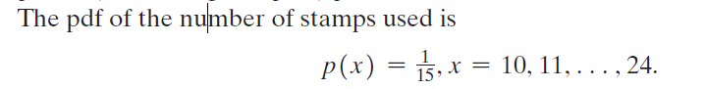

Q8. Overall coal logistic chain involves movement of coal from mine to nearby washery or coal handling plant for value addition. Subsequent to that coal is moved to dispatch point which can be a railway siding, port or inland waterways terminal using road, conveyor, merry-go-round (MGR) train and rail. How can coal India reduce its logistics costs? List any 5 technological interventions that can assist in doing so. (5 Marks)

Q9. Mining workshop needs to assign four jobs to four workers. The cost of performing a job is a function of the skills of the workers. Table below summarizes the cost of the assignments. Worker 1 cannot do job 3, and worker 3 cannot do job 4. Determine the optimal assignment using the Hungarian method. (10 Marks)

